|  |  |
| --- | --- |
|  |  |
|  |  |
|  |  |

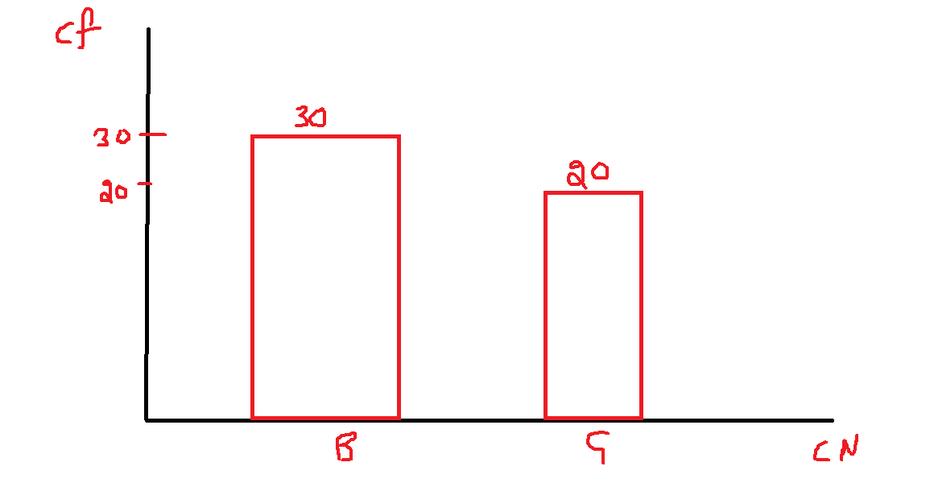

|  |  |  |
| --- | --- | --- |
|  |  |  |
|  |  |  |
|  |  |  |
|  |  | = |

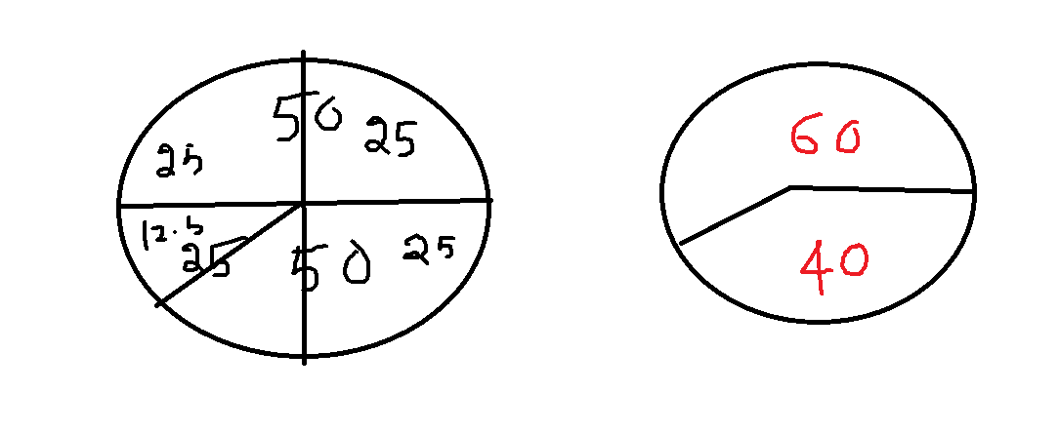

|  |  |
| --- | --- |
|  |  |
| 10-15 | 3 |
| 15-20 | 1 |
| 20-25 | 2 |
| 25-30 | 1 |
| 30-35 | 3 |

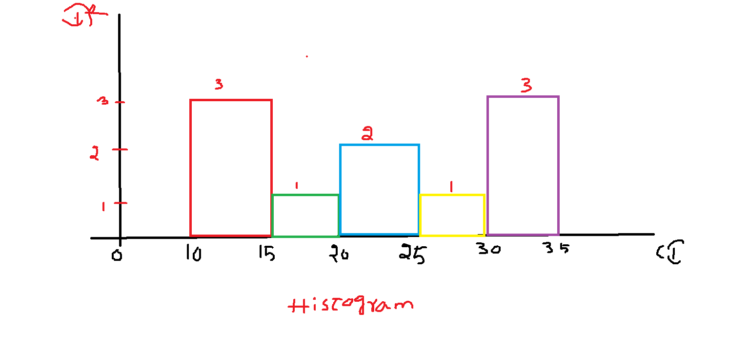

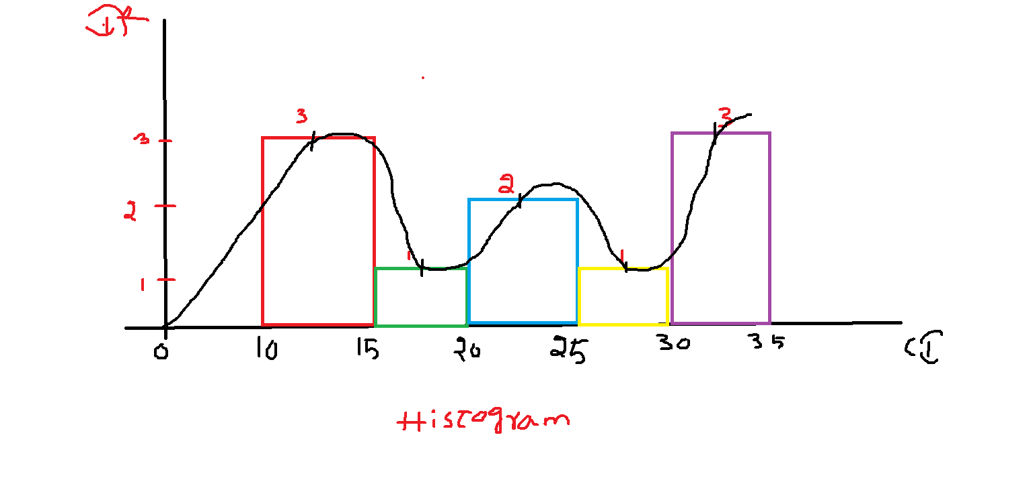

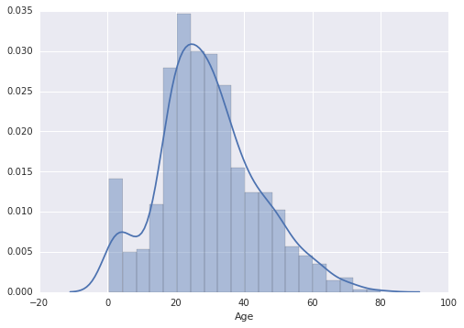

|  |  |  |
| --- | --- | --- |
| Data Type | **Categorical** | **Numerical** |
| Tabular | Frequency table | Frequency distribution table |
|  | Relative Frequency table |  |
| Graphical | Bar chart  X-axis: Class Names  y-axis: Class frequency | Histogram  X-axis: Class Interval  Y-axis: Class Interval Frequency |
|  | Pie chart | Distribution plot |

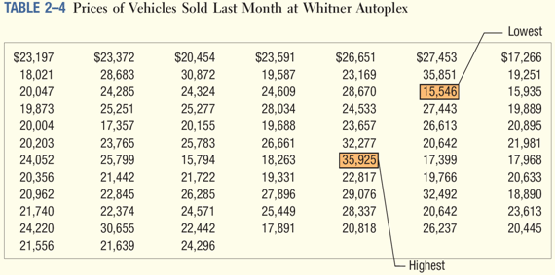

|  |  |
| --- | --- |
| k | 2^k |
| 0 | 1 |
| 1 | 2 |
| 2 | 4 |
| 3 | 8 |
| 4 | 16 |
| 5 | 32 |
| 6 | 64 |
| 7 | 128 |

